Instruction for importing shapefile into DB2 for z/OS
- IPL the EC with the following setting
  - Change the New Catalog to N – prevent erasing existing data when re-IPL (especially every Sunday) – need further investigation (can use Y for now)
  - Type DYN in the TCPIP column
  - Choose MVS ZS21PA - z/OS version 2.1
  - Type NN under 1st DB2 for using DB2 version 11
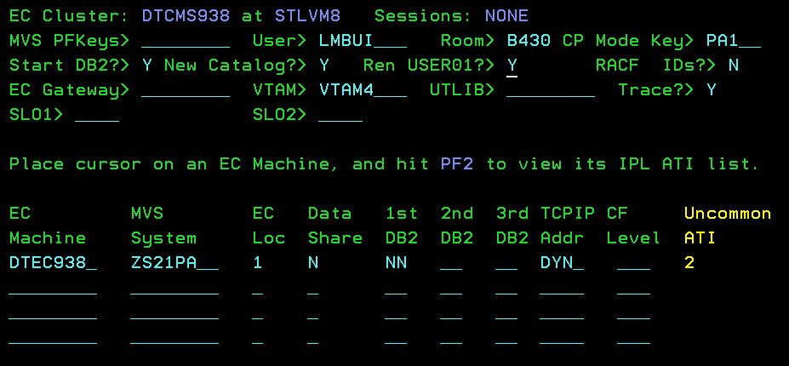
  - Hit F2 on the column “Uncommon ATI”
  - Change the disk space to 600
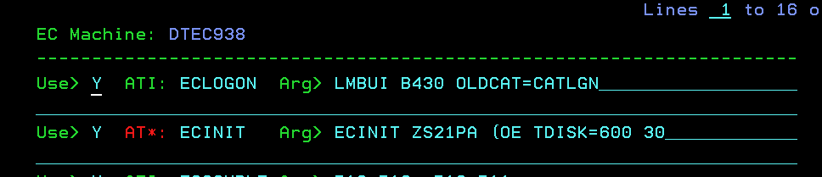
  - Change the command to start DB2 to “-DB2ASTART DB2, PARM=DB2AZNS”. ‘ZNS’ means to turn on ddf and no datasharing.
  - When the EC is up, type -db2a dis ddf to see the db2a TCPIP status. It should contains the IP address.
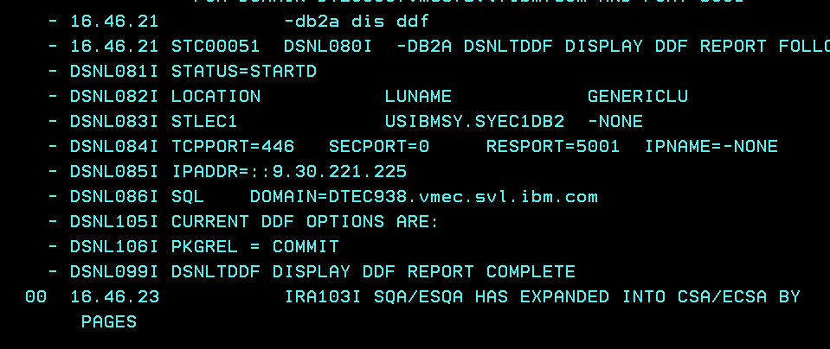
  - If there is no IP, you might want to stop and start db2 manually. The command to stop is “-DB2ASTOP DB2”. The command to start db2 with ddf turn on is “-DB2ASTART DB2,PARM=DB2AZNS”. If you still don’t see the IP address, you would have to set up the TCPIP configuration for the EC (there is instructions for this)

- Go to your VM14, tcpun the job “DSN5SENB PARMV11” to active enable the spatial data for the DB2 in the EC. Check the result if it is successful.
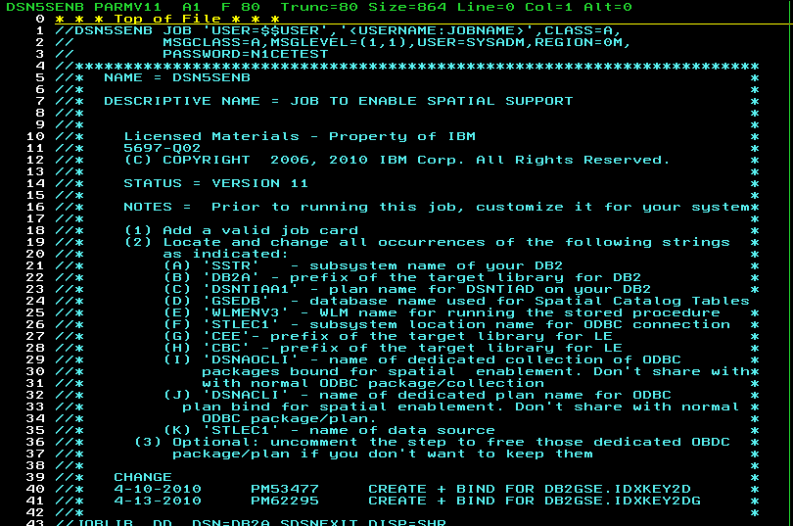

- Install the DB2 for LUW Enterprise version. Choose the following option to install DB2 for LUW. Note: there is another document for instruction to install DB2 for LUW.
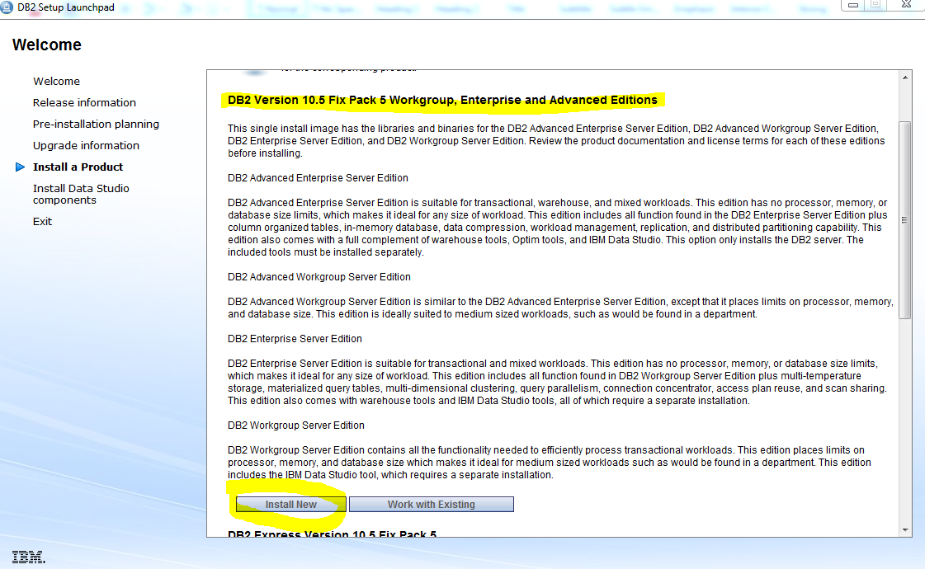
- Open “DB2 Command Window – Administrator” after installing DB2 for LUW.
- Use this script to create a node connected to the EC machine that we set up above. Only change “dtec938” to your machine name. The common database name is STLEC1, same for everyone. Note: make sure that your EC is up and running.
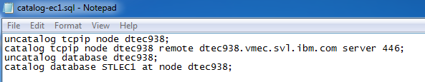

- Change the directory to the folder containing the shapefiles. Then, connect to the database STLEC1 using the following command
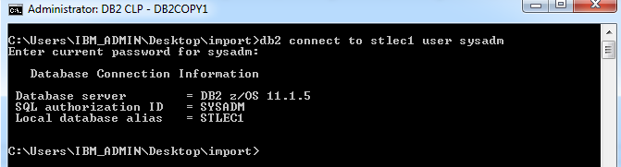

- FTP to your ec using sysadm account and then change the directory to tmp.
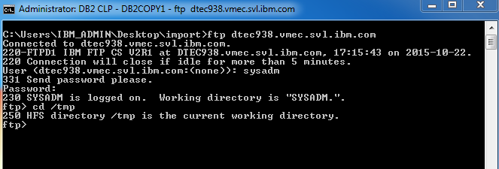

- Transfers the shapefiles into the tmp directory. Note: Use binary mode DO NOT TRANSFER the .prj file to avoid comparing the srs, created in the database and srs specified with the shapefile.
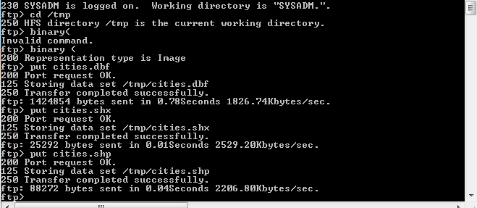

- Type quit to get out of ftp then run the script to create a new Spatial Reference System (SRS). The command to run the script is “db2 –tvf create_srs4326_z.sql”. Note: SRS4326 is the most common coordinate system.
call SYSPROC.ST_Create_srs( 'SRS_4326' , 4326, -180.0, 5000000.0, -90.0, 5000000, 0, 1000, 0, 1000, 'GCS_WGS_1984', 'EPSG4326', ?, ?) ;

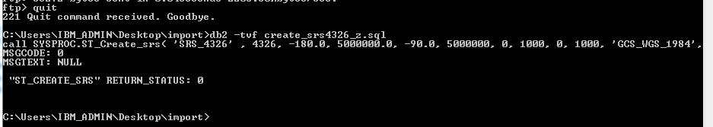

- Run the script the import the shapfile we just transfer to the tmp folder in the EC machine.
drop table SYSADM.cities;

call SYSPROC.ST_IMPORT_SHAPE( '/tmp/cities.shp', NULL, 'SRS_4326' , 'SYSADM', 'CITIES', NULL, 1, NULL, 'SHAPE', NULL, NULL, NULL, 'OBJECTID', 1, NULL, 1000, '/tmp/spatialExcpMessag1.txt', '/tmp/spatialShapmessage.msg', ?, ?) ;

call SYSPROC.st_register_spatial_column('SYSADM', 'CITIES', 'SHAPE', 'SRS_4326' , ?, ?);

select varchar(db2gse.st_astext(shape),40) from SYSADM.cities fetch first 5 rows only;

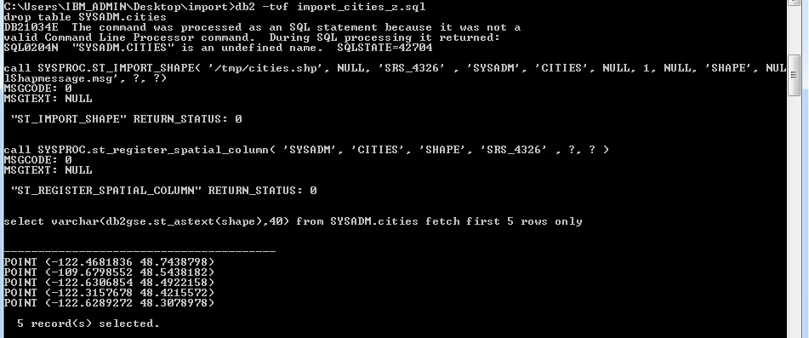

DONE!!!

